[7:-8] (array([-43.47473114, 42.06537227]), array([[ 0.34999123, -0.41011602],

[-0.41011602, 0.4806157 ]])) 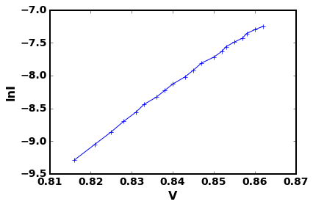

[8:-8] (array([-43.34480166, 41.91344779]), array([[ 0.36314879, -0.42550683],

[-0.42550683, 0.49861842]])) 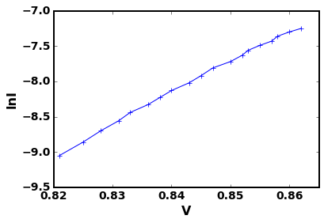

[9:-8] (array([-43.18560054, 41.72735907]), array([[ 0.37012084, -0.43355027],

[-0.43355027, 0.5078949 ]])) 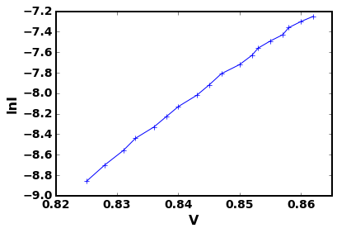

[10:-8] (array([-42.99374084, 41.50318706]), array([[ 0.38497299, -0.45081751],

[-0.45081751, 0.52796738]])) 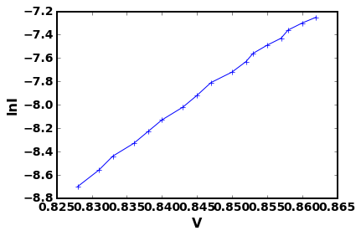

[11:-8] (array([-42.8451669 , 41.32965928]), array([[ 0.41518975, -0.48604374],

[-0.48604374, 0.56903315]])) 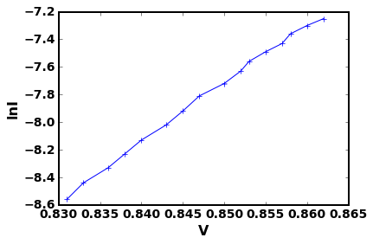

[12:-8] (array([-42.62746344, 41.07537876]), array([[ 0.44787301, -0.52426914],

[-0.52426914, 0.61374055]])) 